DOUWE ATTEMA

AGILE TRANSITION COACH
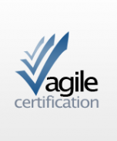
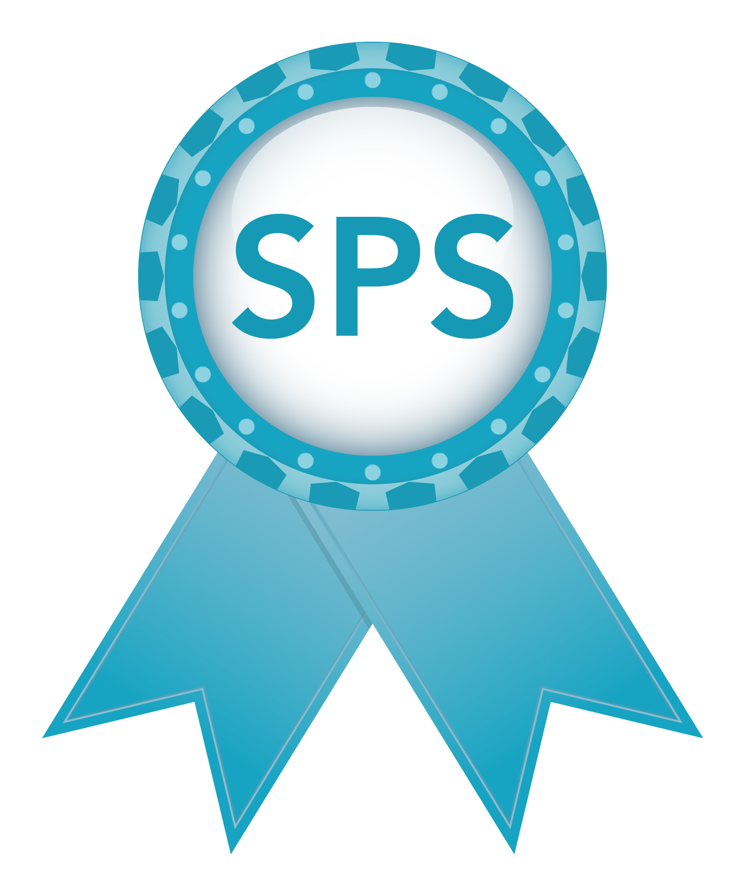
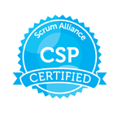
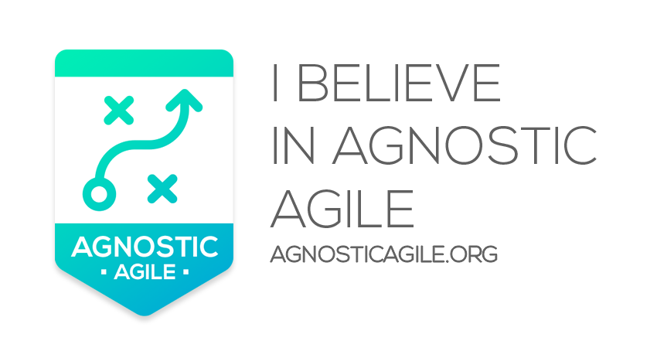
ATTEMA EXECUTIVE MANAGEMENT & COACHING
Web: www.douweattema.com
email: douwea@gmail.com
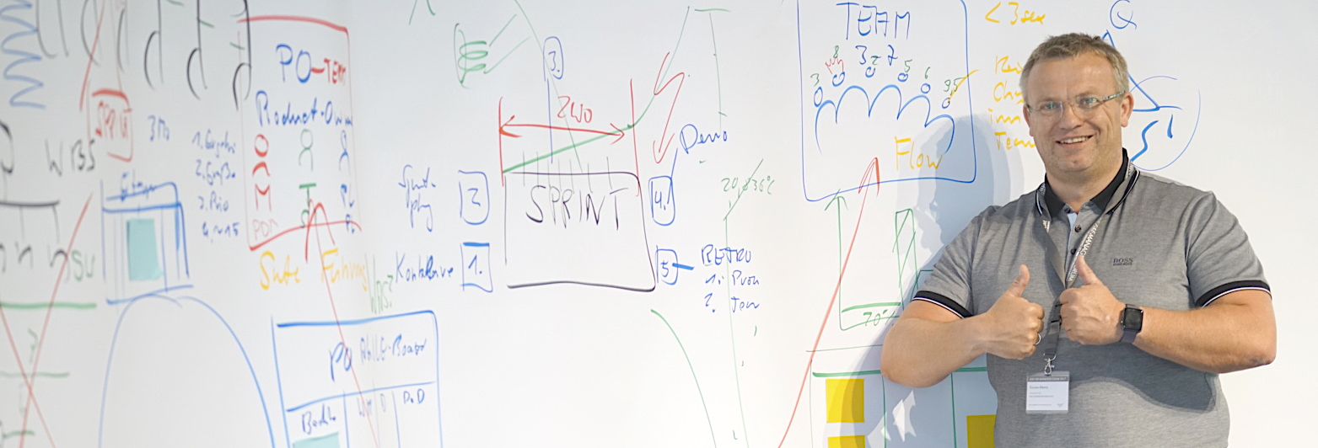
Phone: +31 (0) 622 0354 22
Twitter @douweattema LinkedIn: https://nl.linkedin.com/in/douweattema

"More than 30 companies have been successfully served and consulted with their Agile Transitions and Implementations journeys."

Introduction :
As an Agile Transition Coach / Agile Consultant I have more than twenty years of experience in helping organizations become more Agile by initiating, implement and accelerate the Agile Way of Working including the Agile Mindset. It is not only about introducing a methodology but also creating more awareness. in organizations with regard to what is possible and the choices that become available you see more creativity and more happiness. When having choice, a real Agile Mindset becomes available. More than 30 organizations have been successfully facilitated and are able to deliver more value more effectively and efficiently with more consciousness and happiness. They can adapt better and are more flexible acting on customer demands and customer choice.

I coach leaders (management and team leadership) and knowledge workers in creating a measurable, agile and sustainable organization. I am able to transform organizations in this way so that they work with more pleasure, ease and joy, whereby the organization becomes more Agile and productivity can also increase between 200% and 400%. My backpack contains not only the knowledge through obtaining certificates, but also practical knowledge that I have gained through years of experience, so that I can apply what is applicable to certain situations. I facilitate Agile and Lean transformations in small to medium-sized companies, varying in commercial organizations, government and large corporations.

What else is possible?

Specialties:
- Agile Transition Coaching

- Agile Team Coaching,

- Strategic Agitator

- Interim management

- Coaching

- Agile Scrum

- SAFe 4.5, SAFe for Lean Enterprises 5.0.
( Essentials, Large Solution, Portfolio, Full)

- Nexus (SPS), LeSS , Kanban, DevOps, BusDevOps

- Lean, Six Sigma, Toyota Kata, ASL, BISL,

- ITIL, Service Management, Change Management,

- Agile Transition Programs,
Agile Acceleration Programs,
Agile Initialization Programs
Skills:
- Facilitating, Open Mindset, respect for everyone, Trusting each other

- Building long lasting relationships. Managing environment and Stakeholders (managers, customers, business, project management)

- Communication (non-verbal and verbal), Full Software Lifecycle Management (ALM)
- Distributed data modeling also global models
- Available as Scrum Master, ProductOwner or Release Train Engineer
- Agile Project Velocity Management
- Agile metrics

- Setting Up and Maintaining Obeya Rooms

- Obeya Performance Facilitate Dialogue

- Backlog management and Backlog preparation

- Writing, resizing and trimming Userstories / Features / Epics
- StoryMapping, Storytelling
- portfolio management

- Release schedule

- Agile Frameworks such as Scaled Scrum, Nexus (SPS), LeSS and Safe to manage and coaching

- Agile event management and facilitation

Experience overview

Agile Transition coach (Partner)
Axel Schröder & Partners
www.asup.de

As an Agile Transition Coach and as a Senior Advisor I am a partner of Axel Schröder & Partners (AS&P) ( www.asup.de ). I am deployed as an Agile Transition Coach on Agile Transition Projects in Europe, among others in the Automotive, Electronics and Mechatronics sector where integration and complexity play a major role.
Implemented Agile implementation, acceleration and transformation projects at, among others: Thyssen Krupp Presta, DELPHI Automotive systems, Chassis Brakes International Paris, Osram Venice, Zehnder Zwolle

Agile Transition Coach / Owner
Attema Executive Management & Coaching
Agile implementation , acceleration , education and _ transformation projects at various beautiful clients including : Rabobank, de Volksbank , APG, KPN SP (Next Gen Critical Communications), Vijfhart Education , University Nijmegen, NN investment Partners, ThyssenKrupp -Presta (Budapest), Shell Global Services, Zilveren Kruis , Rijkswaterstaat, Alliade , Van Oord, Wortell , Chassis Brakes International (Paris), Zehnder, Tele2, Nedtrain , Environment services Haaglanden (ODH), Environment services Groningen (ODG), Xs4all, NAM SHELL, Alliander , Marel Stork, Department of Infrastructure and Environment (ILT), CIBIT Academy | Inspearit , Chamber of Commerce (KVK) , Ajilon

MOTTO
Only when you really work together you achieve great results and really grow people

To be proud of
The decision to work independently and independently to help organizations become agile and grow employees.
Perseverance & Loyalty
When I commit to assignments, I will give full focus and dedication. I will give 100% to accelerate organizations, teams and individuals with the starting point for people to grow.

Languages
Dutch
English
German

Training, Certification
HTS Electronics / MTS Electronics / LTS Electronics
Certified Scaled Professional Scrum (SPS) (NEXUS) (scrum.org)
Certified Agile Transition Coach (AS&P) www.asup.de
Certified Product Owner (AS&P) www.asup.de
Certified Scaled Agilist ( SA) Leading SAFe 4.5 / 5.0
Certified Agile ScrumMaster and CSP (ScrumAlliance )
Certified Agile Advanced Practitioner (Agile Consortium ) PSM1 and PSM2 (scrum.org
ITIL Service Management 2.0 and 3.0
Prince 2 Foundation
Awareness in organizations through Access Consciousness
Access Consciousness Bars Facilitator
Access Body process Facilitator
Access Symphony of Possibilities (SOP) Practitioner
Access Consciousness Facelift Facilitator
Access Consciousness Foundation (practitioner)
Relationships Done Different (RDD)
Business Done Different (BDD)

OVERVIEW RECENT ASSIGNMENTS
Rabobank
AD INTERIM Agile Coach / Scrum Master
November 2021 – April 2022
Guiding in the ScrumMaster role of 3 teams in business Lending Retail/Corporate. Streamline Agile Scrum philosophy based on ScrumGuide 2020 and Scaled model Rabobank. Team and individual coaching of team members.
Make adjustments where possible for the benefit of high performance teams objectives. This is a temporary arrangement until internal ScM is found.

De Volksbank
Agile Transition Coach
January 2021 – October 2021
Starting up and guiding a new Agile organization.
In the first phase, guiding the initialization team in which the new Agile oriented organization was shaped based on ScrumGuide 2020 and LeSS principle. Shaping the architecture of the transition by designing customer journey areas, staffing and the division of roles and team divisions. Together with 13 other coaches, we started in April 2021 with the composition of the teams and the design of the entire organization. Budgeting, Dialogues and the design of communication between teams and organizational units.

APG
Agile Value Stream Coach
Dec 2019 – Dec 2020
Coaching the teams and the Valuestream (SAFE4,5) with a focus on team and valuestream maturity and behaviour. Intense coaching at team level and on a valuestream management team based on the APG Agile Scaled Model (custom SAFe). Initialized, updated and expanded capabilities for Obeya Rooms and Metrics. Transformation from paper Agile Boards to Jira Boards due to work from home situation (Covid 19), Creation of Way of Working documents related to work from home situations.
KPN
Agile Coach
March 2019 – September 2019
Coaching Scrum teams and organization of KPN SP to work in an Agile way during the introduction of the next generation of critical communication systems such as: Push to Talk, Bodycams, Voice logging and dispatchers. During the assignment (which was also an objective) after 12 iterations there were possibilities to transfer my role to an internal employee.

Nationale Nederlanden (NN)
Investment Partners
Agile Transition Coach
October 2017 – March 2018
Coaching (25) teams, roles and organization during the transition to DevOps and BusDevOps
Member of a great Agile Coaching Team helping the organization with their Agile acceleration program.
Organizing and facilitating multiple PI events (700+ participants) at remote location. Set up Obeya room and facilitate Obeya Room Performance dialogues with teams, management and stakeholders. Performed Agile maturity measurements and facilitated performance dialogue with teams and management.

ROYALL SHELL Head Office The Hague
Senior Agile coach
October 2017 – March 2018
Agile Coaching on SM, PO roles and at Portfolio and Project Management level within existing Agile Edge 3.0 Shell Framework, based on SAFe 4.5 and Lean Frameworks). Introduction of 1 point of contact (Single point of contact) for the business units (Agile Center of Excellence) has led to the development of locally based Agile coaching capabilities and support with regard to coaching needs in Agile (edge 3.0) and waterfall projects. Support, coaching and training.
Mentored junior Agile Coaches in the IT business line of the Global Functions business unit .
Thyssen Krupp Budapest/Liechtenstein
Agile Coach
January 2016- September 2017
Guiding and Coaching Agile Teams in Budapest and Liechtenstein to build an iterative smart steering column system for Ferrari, BMW and Audi. Implementation and facilitation of Agile Events, Portfolio and product back log management. Introduction and implementation of integration teams based on the NEXUS model (SPS)
IND via ODINTAKT
Associate Partner (Agile Coach, Lean and Toyota KATA)
June 2015 - December 2015
Living through and implementation of the Toyata Kata (improvement and coaching kata) process for the Immigration and Naturalization Service (IND) with regard to the process inflow and outflow of immigrants.
XS4ALL Internet BV
Agile Coach
January 2014 - December 2014
Coaching multiple Agile Scrum / Devops and Kanban teams, creating more awareness about the collaboration between ICT and the business so that people can be more successful in accelerating product and service development. Advice given regarding incident management versus new functionality within Agile Scrum method, Advice given regarding financial hour administration versus Velocity in Agile Scrum . Focused on working as a team and not individually. More efficient decision making on backlog in multiple teams with multiple product owners, introduced diversity in Retrospectives ceremonies. Optimization made in mapping process Portfolio backlog to Product backlog
(epic / features / story)

RECOMMENDATIONS AND REFERENCES
LENNEKE ROESCHER RABOBANK
Business Lending Corporate.
Douwe has helped us as a senior ScrumMaster who transformed a Scrum team moving forward with a healthy dose of humor and an eye for diversity. Douwe is able to quickly implement small adjustments that immediately help the team further in addition to implementing structural improvements to become a high performance team. In a next assignment I would rather use Douwe as an agile transition coach. He brings structure to meetings, makes certain issues transparent and decidable. His overall helicopter view enables him to simplify complex processes and promote collaboration within the possibilities there are.
DAVE VAN HERPEN, APG
Douwe is an enthusiastic and professional coach with a lot of experience in the Agile way of working. He has been a valuable addition to the APG Agile Transformation and implementation team, where he has shown that he is able to deal with complexity. He is flexible in adjusting the theoretical and practical parts of Agile transformations always keeping the Agile Mindset and the values as the base of the journey.
MAURITS ROST, NATIONALE NETHERLANDEN IP
We at NNIP are in the transition to an Agile based company. We hired Douwe to take the next step in our journey. He helped shake up the status we were in after 2 years of implementation. Transforming from a component-based structure to a product-based structure. He helped us sail the ship to a beautiful island (the metaphor we used so often in retros ). The state we are in now is certainly a few steps further. Having a 4-yearly PI event where we plan a next quarter with all teams (incl business and stakeholders) (700 people!). We had never done this before. I will never forget the game element and the fun in the events that Douwe always promoted. This resulted in more openness, vulnerability and understanding towards each other and growth of employees. As he says: make people great! Thank you Douwe for the great results we have achieved.
AXEL SCHRÖDER, CEO AS&P
Douwe is one of the best Agile transition coaches in Europe. As one of AS&P's Associated Partners, Douwe fits very well into the AS&P team of Agile Coaches to help organizations in the automotive, mechatronics and electronics industries to initialize, update and accelerate the Agile Mindset. His enthusiasm and passion to not only do Agile, but also to be Agile is very strong. He brings a great energy to your company. A real Agile transition coach who can take your organization to a higher level.

Wendy Manders, Silver Cross
Douwe is an Agile transition coach who can kick off and guide an Agile transition with excellence. In his own energetic way, he knows how to inspire and encourage everyone to go a step further than other Agile coaches, so that people dare to step out of their own comfort zone. At Zilveren Kruis, he coached various teams and organizational units with great positive vibes and energy in their first steps in working with Agile through training, coaching on the job and, where necessary, also entering a sharp dialogue. Together with the internal Agile coaches, he ensured a significant acceleration of the transition. He is someone who likes to get things done and who takes action. His approach is to take responsibility instead of just talking about it. Among other things, he was able to guide the internal coaches so that they could eventually successfully continue the Agile transition on their own.
JEFF SUTHERLAND (Scrum.org)
Douwe showed me that he can also implement the Agile Scrum way of working in an Engineering environment. Douwe applied the Scrum principles to more than 25 Agile Scrum teams at Nedtrain to rebuild and refine existing train cars. It was great to see that he was so enthusiastic about scaling the Agile Scrum method organically in an R&D Engineering department, which initially only focused on quaility gates and long-term project methodologies. Douwe has written a Syllabus about this project, which I was able to receive and read with great enthusiasm. Overhauling train cars by applying my beloved Scrum methodology. Thank you Douwe for this beautiful contribution.
TIM AARTS, LEANSTARTUP advisor
If enthusiasm is contagious, you can see it in the way Douwe works as an Agile and Lean Coach. Douwe is able to make organizations perform and uses a smooth and enthusiastic active style. Thinking first is sometimes useful, but Douwe is more of the action. If it doesn't work, we try something else that is what he stands for. Then at least you learned from it. Always nice to hear what he does and what he tries to make people grow by also allowing experiments (which can also fail of course) so that people learn.
Aad Harteveld, Owner Xantara-IT
I have experienced Douwe as an honest, hardworking professional. Even in times of adversity, he continues to move in the agreed direction. Douwe works independently, but also in teams and knows how to motivate people in organizations to update improvement initiatives.
HENNY RIETVELD, Service Manager (IND)
Douwe is a very pleasant person and has a lot of humor. He definitely has a clear vision on how to implement a well-run service management organization. He is able to use different types of management styles in a servant and situational manner, which is why he is Situational and Servant Leadership. Where possible I would like to work with Douwe again.

